**Head-movement**

Three types of Movements under the **P&P** framework

1. model:

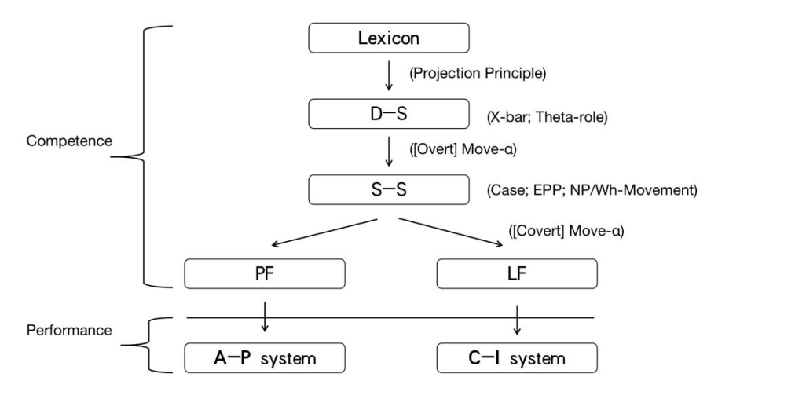

1. Head movement: movement from a head to another head position

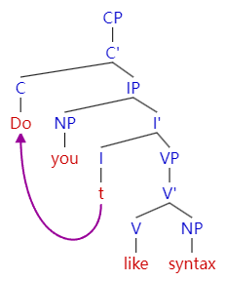

1. NP-movement: movement from an argument position to another argument position (Spec, IP). [A-movement]

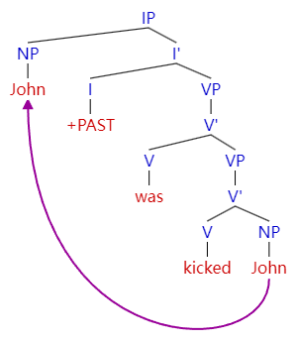

1. Wh-movement: movement of a wh-constituent to Spec, CP. [A’-movement]

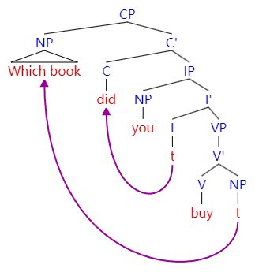

Head movement:

什么是中心语head？

Spec, Adjunct Head Complement

X0: NP N0 VP V0

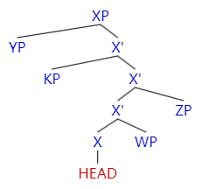

有哪些中心语移位的语言现象？

**V to I movement**

Aux VP V0 I +PAST

Affix hopping I+PAST -> V0

Verb raising V0 - I0 should might

法语 所有动词移到I上。

[I 动词 [VP 副词 V t]

**I to C movement**

一般疑问句 Do...

You I0 do like syntax

Do you like syntax

**V to v movement** (**VP-shell hypothesis**)

Larson 1988 双宾语

I gave Mary a book.

[vP [v’ [v gave+v] [VP [Mary] [V’ [V t] [a book]]]

中心语移位操作的动机是什么？

V- I I0 Strong feature I0 weak feature

I - C C0 [+Q] [-Q]

移位操作如何推导？

vP v VP V